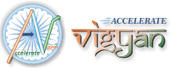
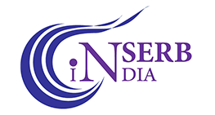
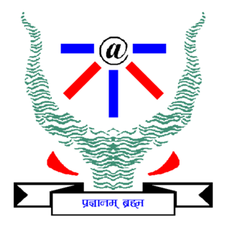
INDIAN INSTITUTE OF INFORMATION TECHNOLOGY ALLAHABAD
Jhalwa, Prayagraj, Uttar Pradesh-211015
ADVERTISEMENT OF INTERNSHIP PROGRAM (VRITIKA)

Applications are invited for short-term (4 weeks) research internship/training under the SERB Accelerated Vigyan Programme - Vritika titled “Study of antibacterial, antibiofilm and anticancer activities of metal
nanoclusters.”

Objective: A winter training program on will be held at the Indian Institute of Information Technology Allahabad from 28th November to 30th December 2022. The primary goal of this program is to showcase the emerging novel trends in the field of basic and applied Biotechnology. Over 80% of microbial infections including many chronic diseases in humans are associated with bacterial biofilm. Due to weakened activity of antibiotics in the inherent acidic microenvironment of biofilm, cells in biofilm develop an extreme level of resistance to antibiotics. Therefore, developing a potent agent against such drug resistant bacterial infections is highly desirable. Recent studies have demonstrated that nanomaterials can be exploited as highly efficacious antibacterial and antibiofilm agents since they fulfill the dual purpose of a drug carrier as well as a potent bactericidal agent. Therefore, we will develop of advanced nanomaterials (eg. metal nanoclusters) as potent antibacterial and antibiofilm agents to combat drug resistant bacterial infections.
Eligibility: Candidates currently pursing B.Tech/MSc/MTech students or Ph.D. (preferably Ph.D. first year student) in Biotechnology and allied areas from University/Institution/College and having a good orientation towards scientific research may apply.
Internship Details:
- Mode: Offline
- Duration: 4 weeks (November 28, 2022 to December 30, 2022).
- Certificate will be provided to the interns after the successful completion of the internship tenure (Submission of work report).
- Nature of support:
- The internship will be given for meeting daily necessary expenses such as stationery, consumables, accommodation, food, etc.
- The participating students will also be eligible for TA reimbursement for their journey to the host institute from their hometown/home institute, both ways, as per GoI norms.
- Course Material and Lab Access will be made available during the internship.
- Stipend: No scholarship/stipend will be given.
Number of Candidates: 02
Last date of Application: 15th November, 2022
Note: The applicant should produce a bonafide letter from the Head of the Department indicating the current association with the Institute/University/College and No Objection Certificate allowing the student to undergo internship offline before joining the program.
Interested candidates may submit their application by sending your complete CV on samantasintu@iiita.ac.in

Event Organizer

Dr. Sintu Kumar Samanta
Assistant Professor
Department of Applied Sciences
Indian Institute of Information Technology Allahabad
Email: samantasintu@iiita.ac.in

